Start at the Waukee Schools webpage: <https://waukeeschools.org/>

Click on the P sign



Login to PowerSchool:

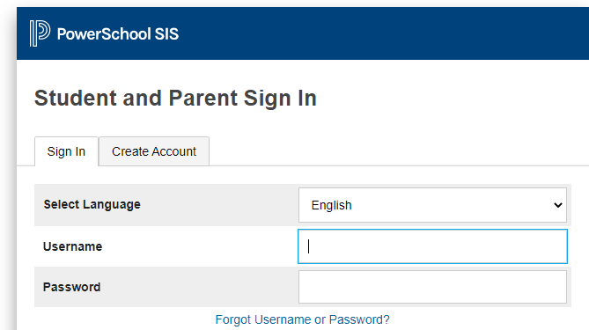

Click on “Balance” on the left side of the screen

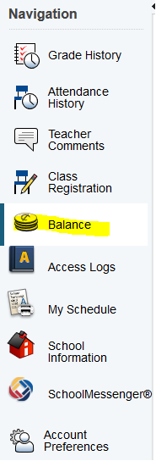

Click on “Make a Payment”

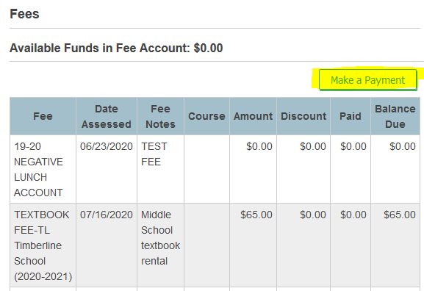

You will see the required fees, Click on “Add to Cart”

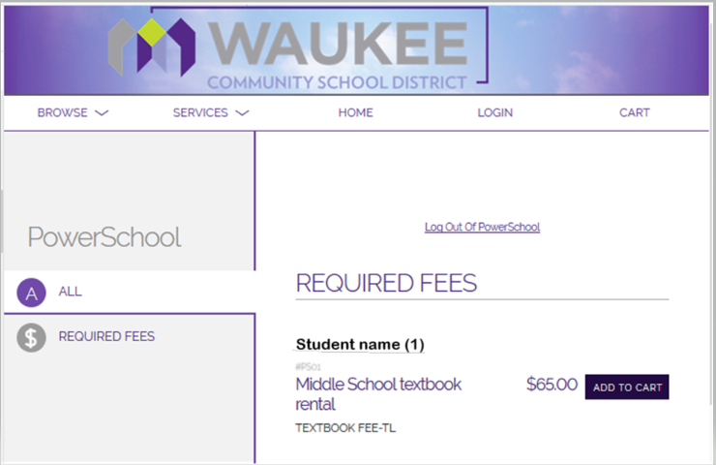

Cart once fees are added

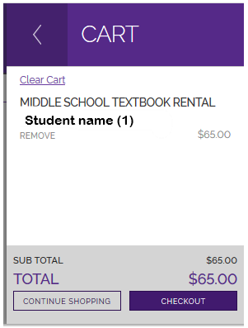

You may continue shopping & add items such as class dues, yearbooks, parking passes & etc. before you checkout.

Login into Revtrak, Checkout & Place Order

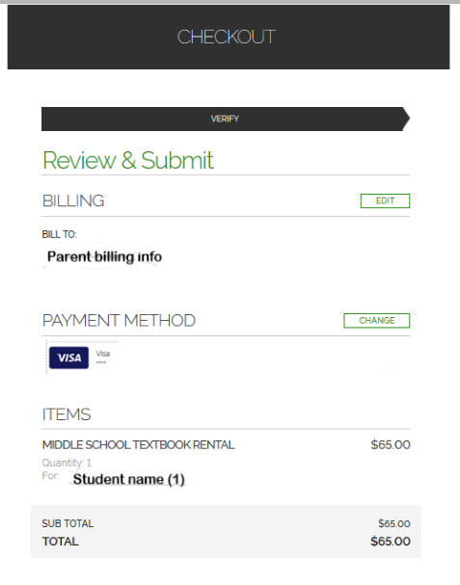

Done! ☺ Thank you!